CREDIT CARD DEFAULT CLASSIFICATION

## Low Level Design (LLD)

Santhosh Kumar K S

## NOVEMBER 2, 2023

INEURON

# INTRODUCTION

### What is Low Level Design Document?

Low-level design refers to the process of specifying and defining the detailed design of a software system. This Low level Design focuses on the implementation details of a system and is concerned with how the system will be built and how it will function at a detailed level. It provides the foundation for high-level design, which defines a system's overall architecture and design.

### Scope of Low Level Design Document?

Low-level design (LLD) is a component-level design process that follows a step-by step refinement process. This process can be used for designing data structures, required software architecture, source code and ultimately, performance algorithms.

# TECHNICAL SPECIFICATIONN

### 2.1 DATASET

The dataset was taken from Kaggle (

URL: <https://www.kaggle.com/uciml/default-of-credit-card-clients-dataset>), This dataset contains information on default payments, demographic factors, credit data, history of payment, and bill statements of credit card clients in Taiwan from April 2005 to September 2005.

### 2.2 DATASET OVERVIEW

### The dataset consists of 25 features, 30000 observations. The features are Id, Marriage, Age, Education, 6months payment history(PAY_0, PAY_2, PAY_3, PAY_4, PAY_5, PAY_6), 6 months payment amount(PAY_AMT1, PAY_AMT2, PAY_AMT3, PAY_AMT4, PAY_AMT5, PAY_AMT6) and 6 months bill amount(BILL_AMT1, BILL_AMT2,BILL_AMT3, BILL_AMT4, BILL_AMT5, BILL_AMT6) and default in next month as target variable.

### 1.png

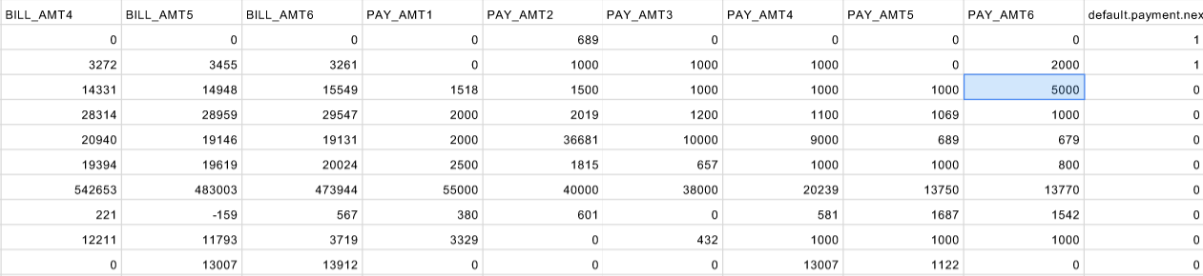

### 2.3 USER INPUT SCHEMA

|  |  |  |
| --- | --- | --- |
| Feature Name | Data Type | Required/Null |
| LIMIT_BAL | Integer | Required |
| PAY_0 | Integer | Required |
| BILL_AMT5 | Integer | Required |
| BILL_AMT6 | Integer | Required |
| PAY_AMT1 | Integer | Required |
| PAY_AMT3 | Integer | Required |
| PAY_AMT4 | Integer | Required |
| PAY_AMT5 | Integer | Required |
| PAY_AMT6 | Integer | Required |

**2.4 PREDICTION**

* UI page displays various inputs provided by the user.
* At the backend these inputs are preprocessed and fed to the trained model to get the result. That result will be displayed in the UI.
  1. **LOGGING**

System logs each and every action into a file. Each backend steps logs into a file. This helps to debug if any error occurred.

* 1. **DEPLOYMENT**

Deployed in local system using Flask web framework.

1. **TECHNOLOGY STACK**

|  |  |
| --- | --- |
| **FRONTEND** | HTML, CSS |
| **BACKEND** | PYTHON , FLASK |

1. **PROPOSED SOLUTION**

Machine learning is a field in computer science aiming to imitate the human learning process. Machine Learning is a branch of Artificial Intelligence where computer learns from the data (past experiences) and makes future prediction. It finds the pattern in data, based on pattern it predicts for unseen data. Here we will develop machine learning models to predict the probability of credit default based on credit card owner's characteristics and payment history.

1. **MODEL TRAINING AND VALIDATION WORKFLOW**

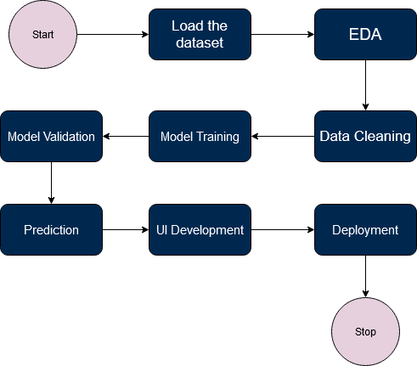

1. **USER I/O WORKFLOW**

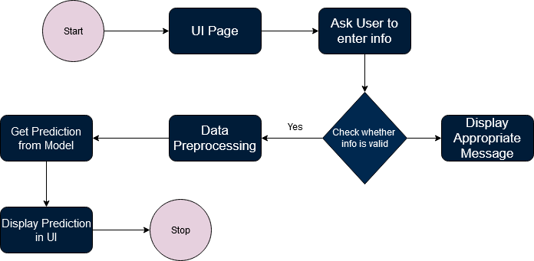

1. **TEST CASES**

|  |  |  |  |  |
| --- | --- | --- | --- | --- |
| Test Case No | Operation Performed | Expected Result | Output Result | Pass/Fail |
| 1 | User Enters invalid input | Should display appropriate message | Displayed appropriate message | Pass |
| 2 | User Enters valid Details | Should display prediction from model | Displayed prediction from model | Pass |